Name:-Panha Patel
ID:-25CE085(CE-2)

Practical 1
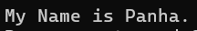
AIM:- Write a simple C program to display your name.
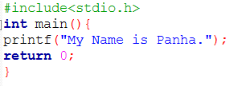

Practical 2
AIM: To calculate the area and perimeter of a proposed rectangular park (70m × 90m) for finalizing its blueprint.
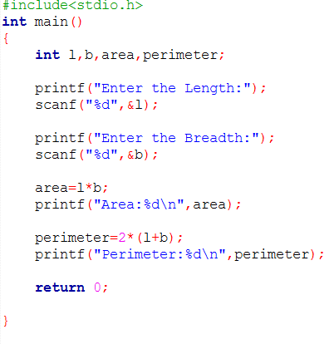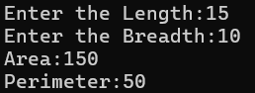

Practical 3
AIM: To develop a simple BMI calculator that takes weight and height as input, computes BMI, and displays it clearly to help fitness center members track their health.

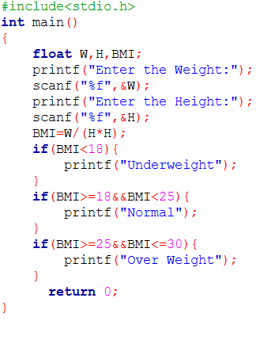
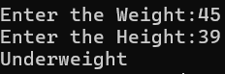

Practical 4
AIM: To create a C program that displays the size and range of basic data types, helping students understand memory usage and value limits for better programming.
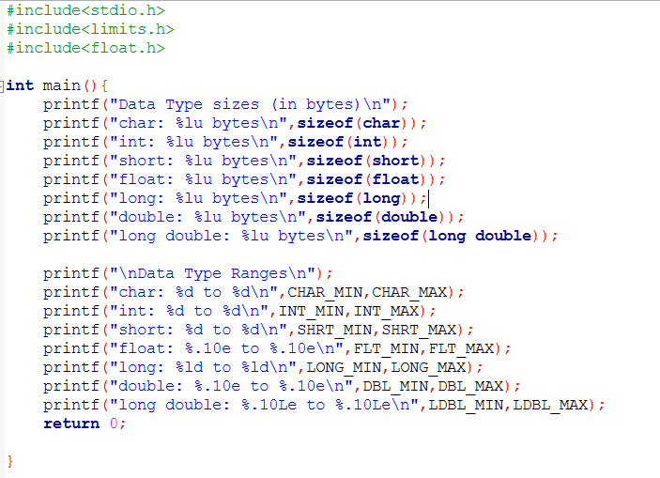
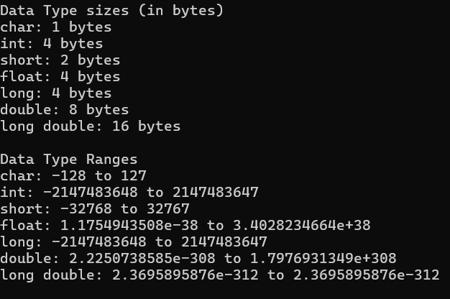

Practical 5
AIM: To calculate the number of illiterate men and women in Bharat (India) for 2024 using population and literacy statistics.

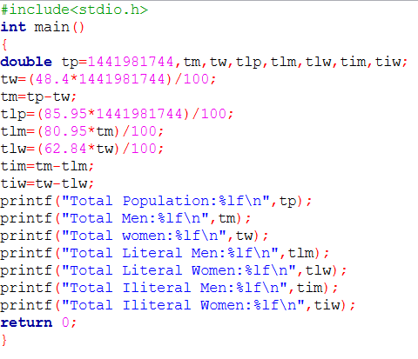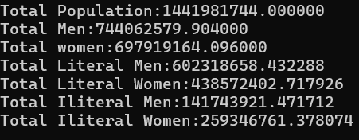

Practical 6
AIM:To convert temperatures from Celsius to Fahrenheit using a formula, aiding global weather reporting.

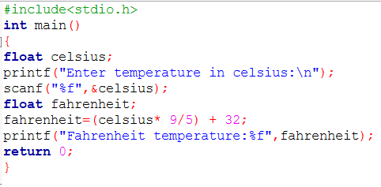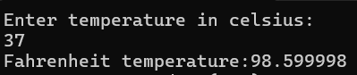
Practical 7
AIM: To build an automated ticketing system that decides free or paid entry based on a visitor’s age.
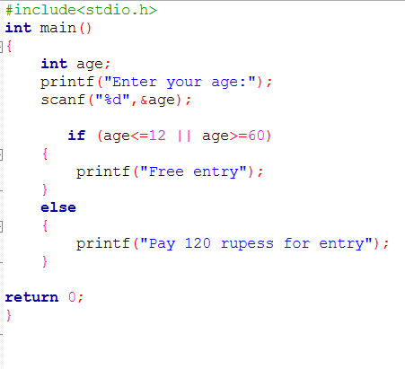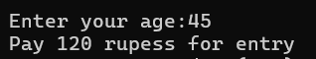

Practical 8
AIM:To design an age-based eligibility checker for Spark Savings Bank to identify qualified applicants for savings accounts.

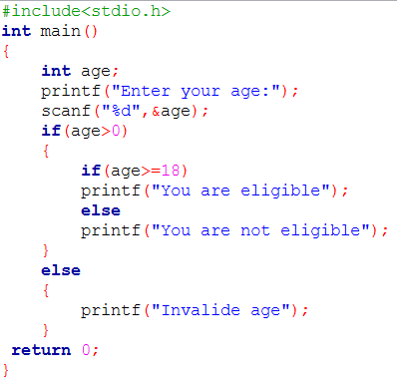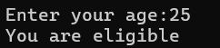

Practical 9
AIM: To develop a discount system for ShopEase Online that applies tiered discounts based on customer spending and displays the total, discount, and final payable amount.
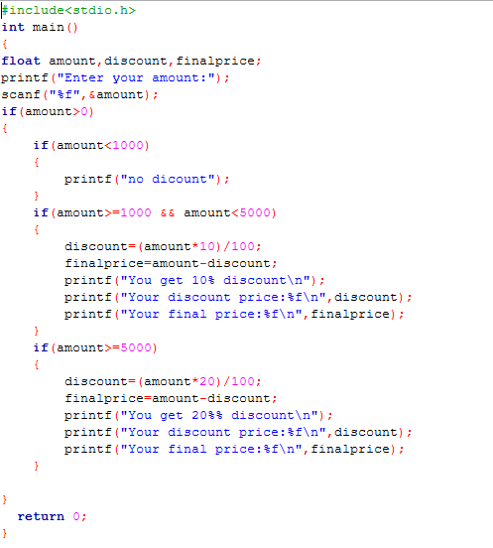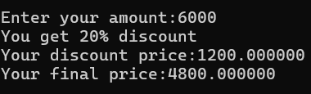

Practical 10
AIM: To create a menu-based ordering system using switch case that calculates the total cost of selected food items at Foodies restaurant.
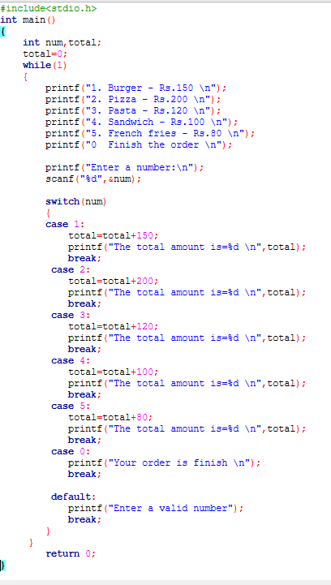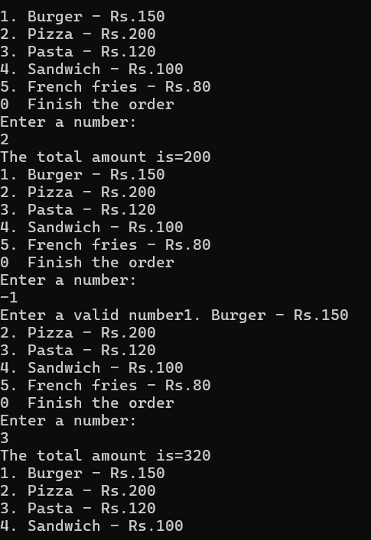

Practical 11
AIM: To create a program using the conditional (ternary) operator that assigns grades based on validated student marks.
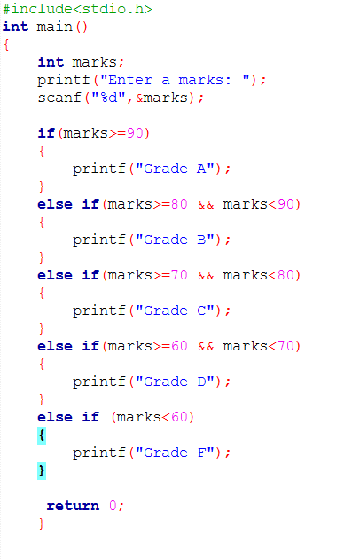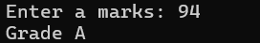

Practical 12
AIM: To generate a catalog of book IDs from 1 to 50, marking every 5th book as a "Special Edition".

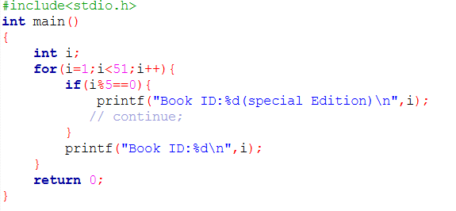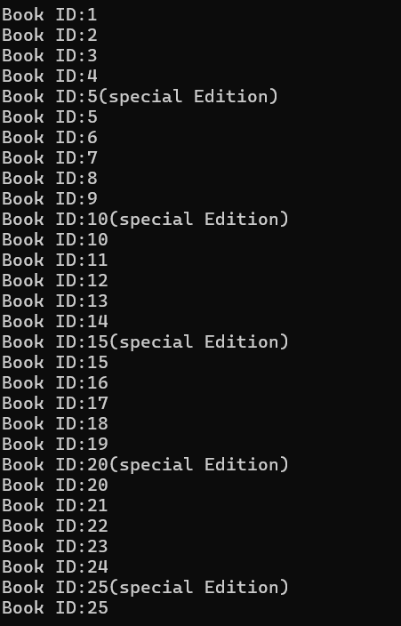
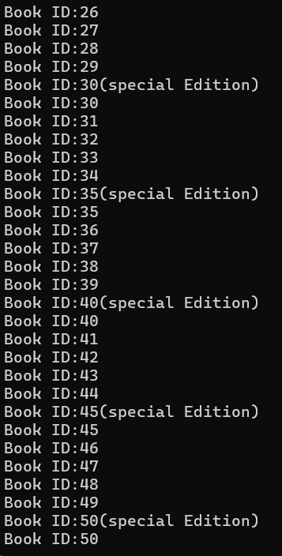

Practical 13
AIM: To simulate an automatic tank refill system that adds water at fixed intervals until full capacity is reached.

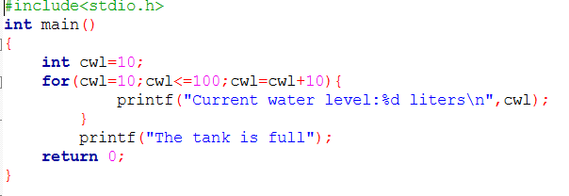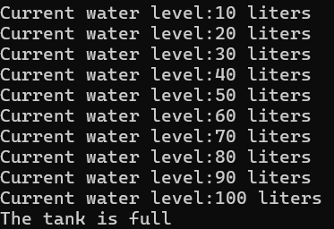

Practical 14
AIM: To simulate an ATM system that allows cash withdrawals, checks for sufficient balance, and updates the remaining amount.
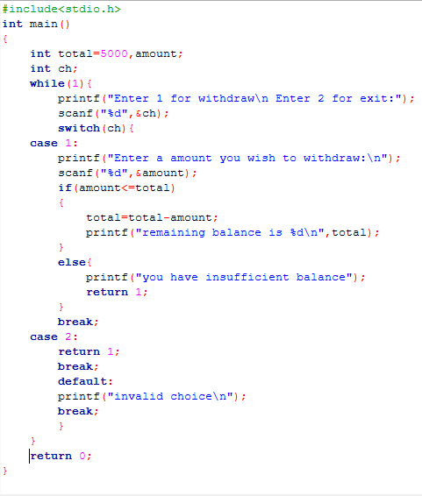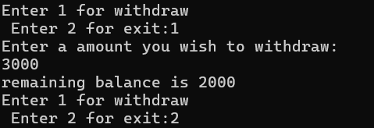

Practical 15
AIM: To develop a countdown timer that decrements seconds from a user-defined start and ends with a completion message.
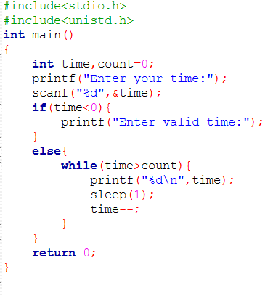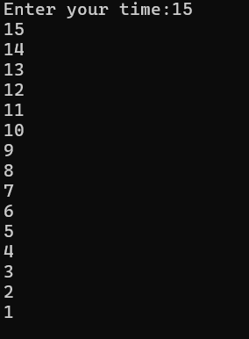

Practical 16
AIM: To create a C program that simulates a matchstick game where the computer always wins by strategic play.
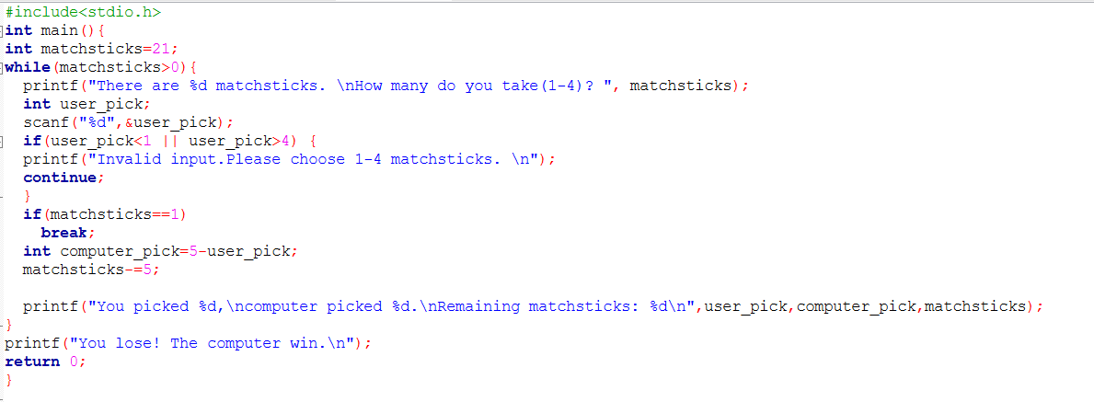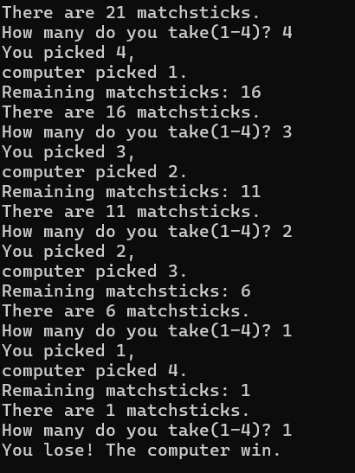

Practical 17
AIM:Simulate a runner's distance tracking during a marathon.
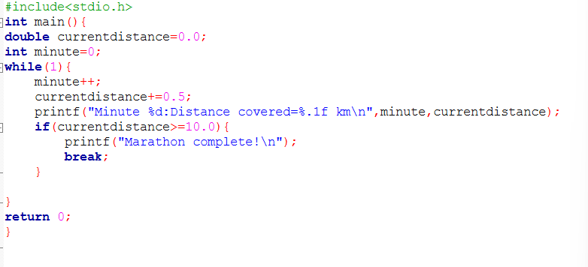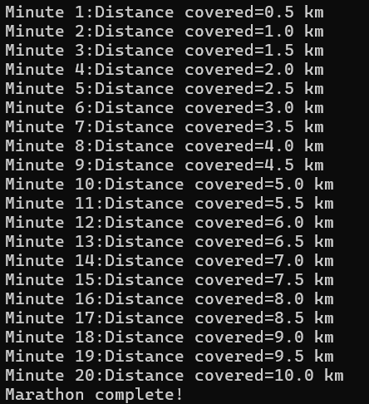

Practical 18
AIM: Create a C program to generate a multiplication table.
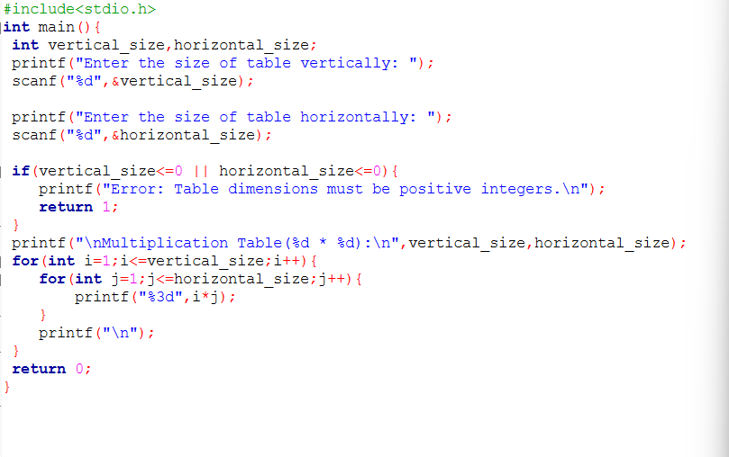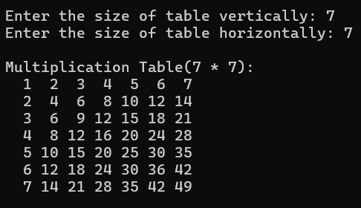

Practical 19 (i),(ii),(iii),(iv)
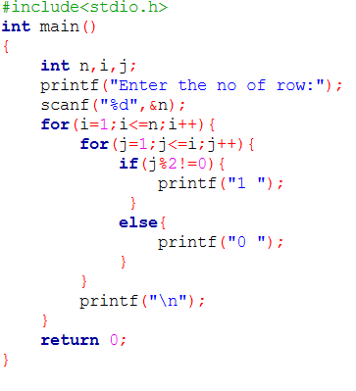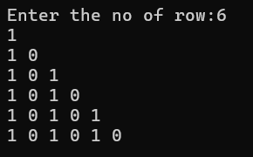
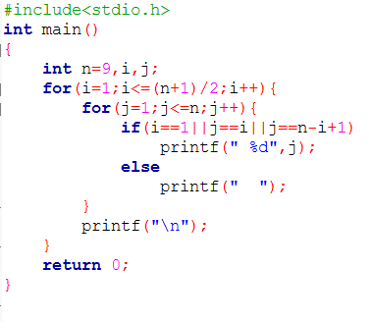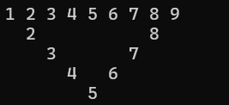
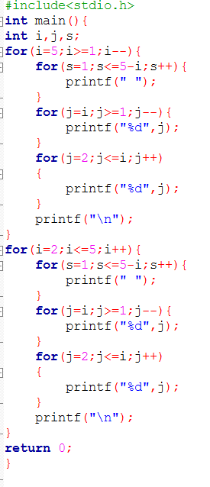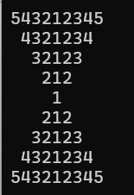
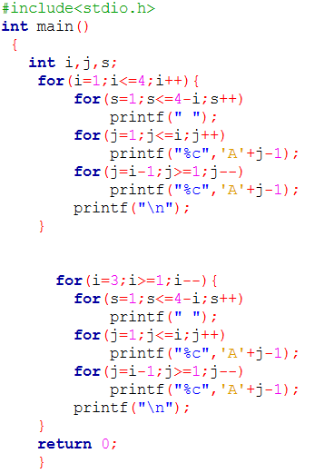
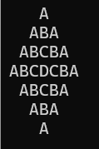

Practical 20
AIM: Identify the missing participant ID from a workshop attendance list.
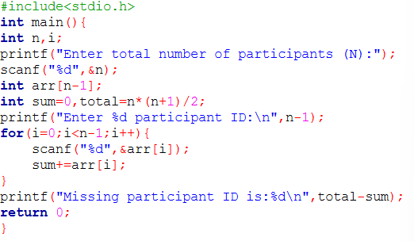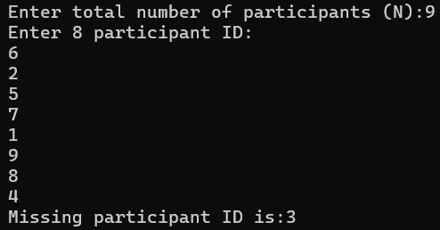

Practical 21
AIM: Build a C program to analyze user-entered integers.
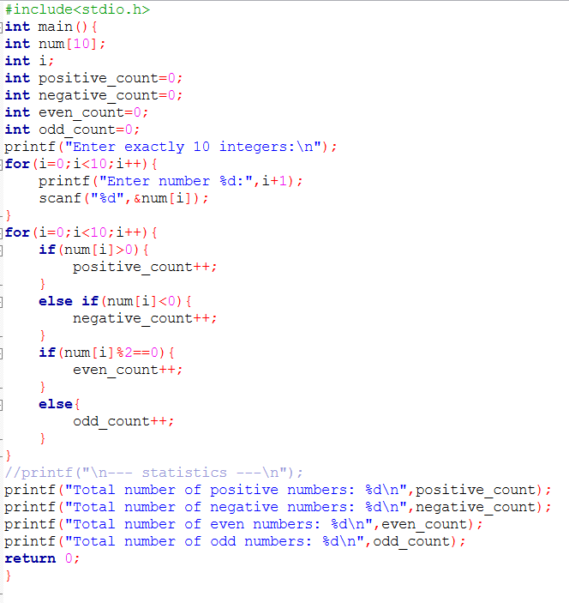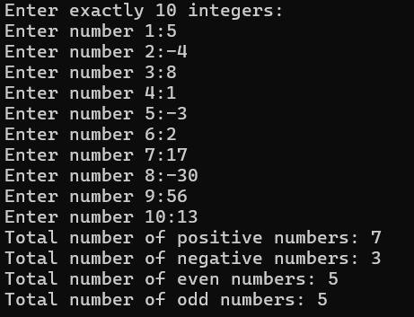

Practical 22
AIM: Display a theater seating chart in C, marking reserved seats with X and available seats with 0.
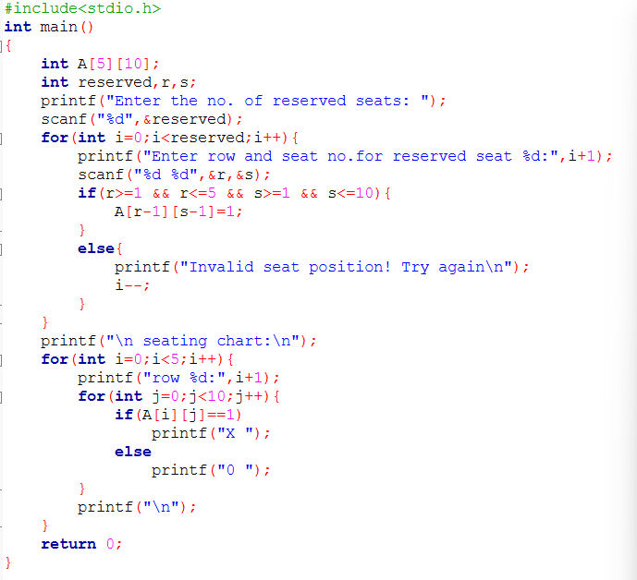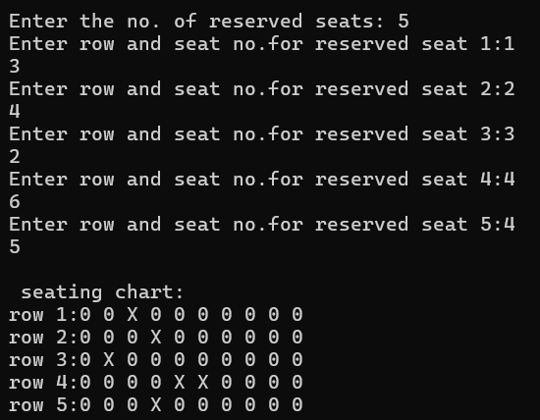
Practical 23
AIM: Find the maximum profit from a single buy-sell transaction on fruit prices using C.
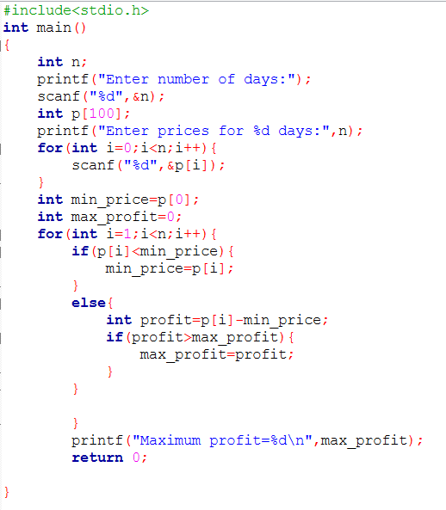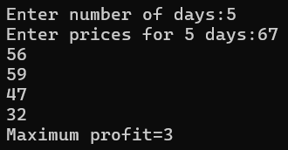

Practical 24
AIM: Build a custom C program for note-taking that manually performs string operations without <string.h>.
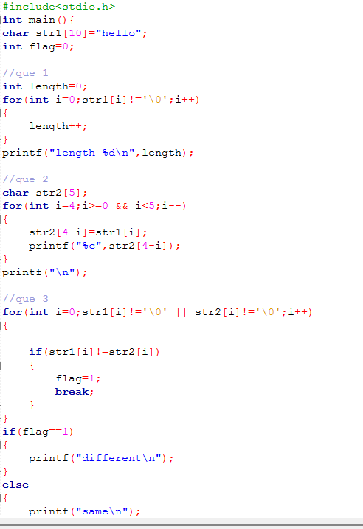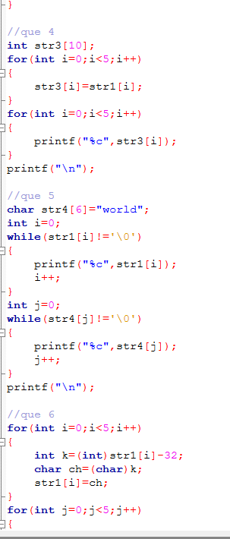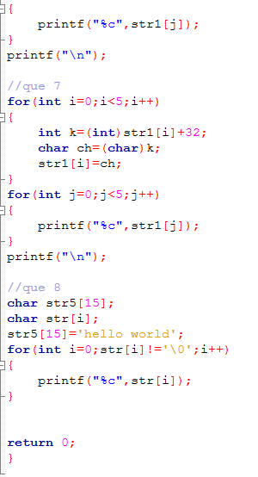

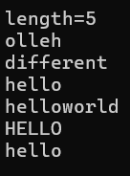
Practical 25
AIM: Design a simple C-based library system with functions for book display, borrowing, and fine calculation.
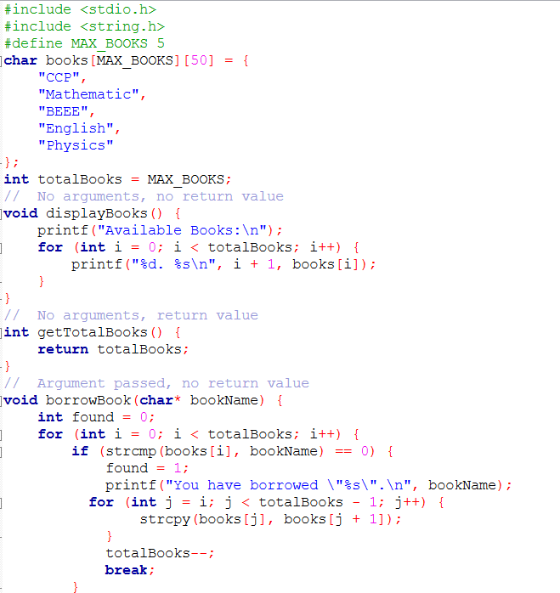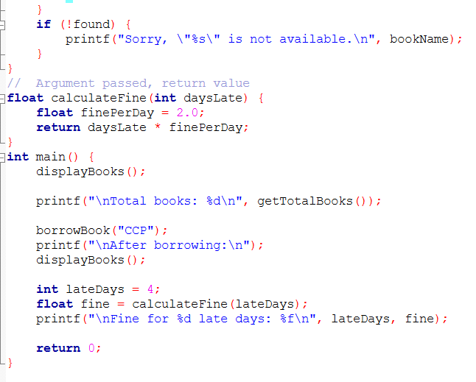
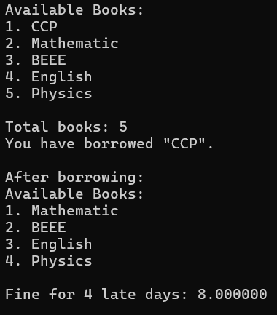

Practical 26
AIM: Validate triangle side lengths and compute area using Heron's formula in a C program.
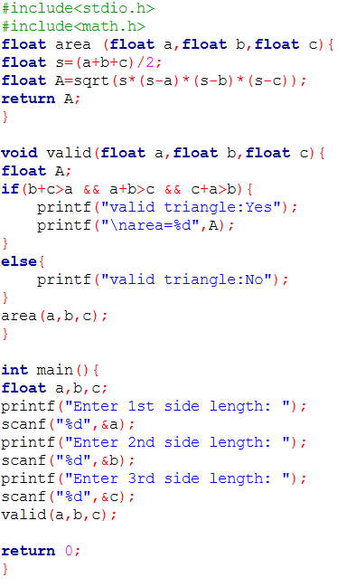
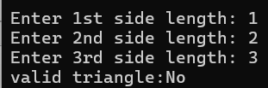

Practical 27
AIM: Generate monthly savings using Fibonacci-like growth to help clients visualize financial planning.
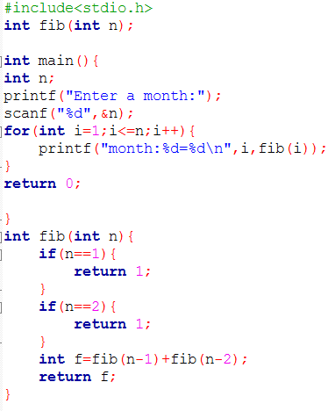
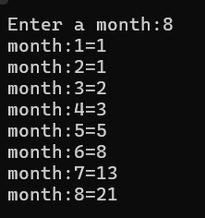

Practical 28
AIM: Create a memory-efficient C program using union to manage and display individual book details.

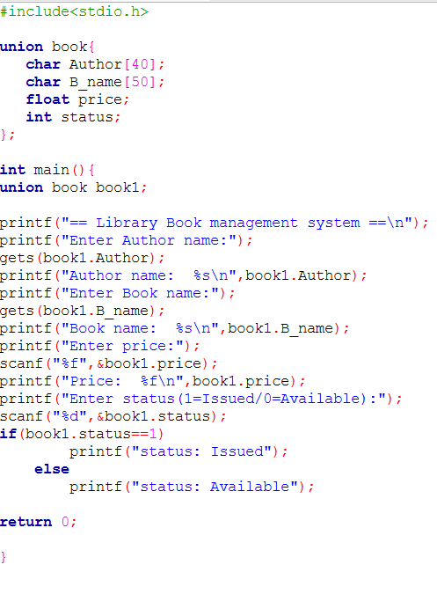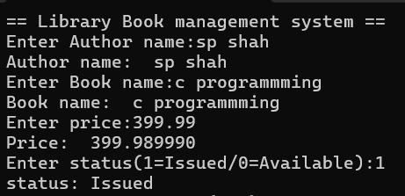

Practical 29
AIM: Build a C program using nested structures to manage sports teams and coach details efficiently.
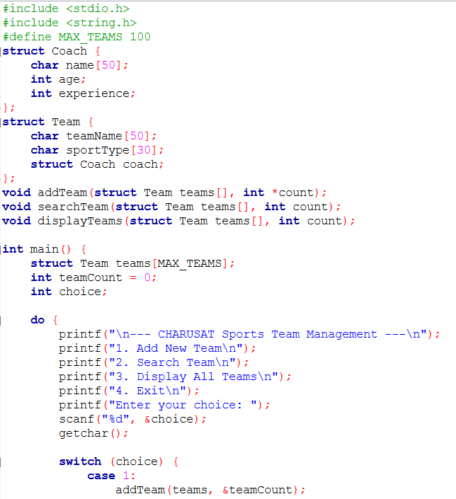
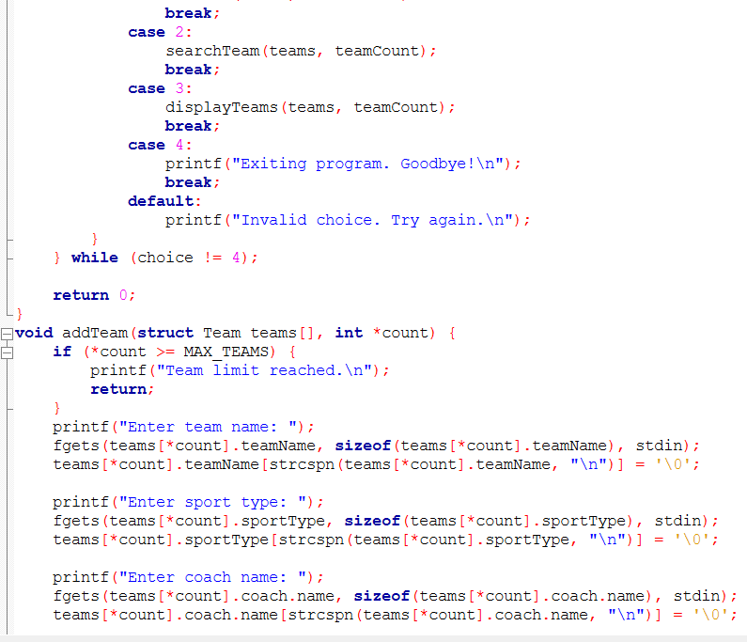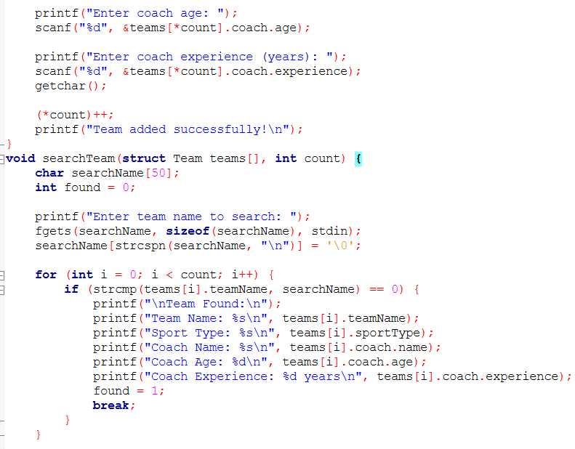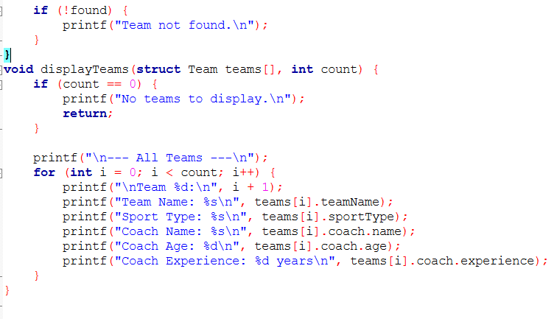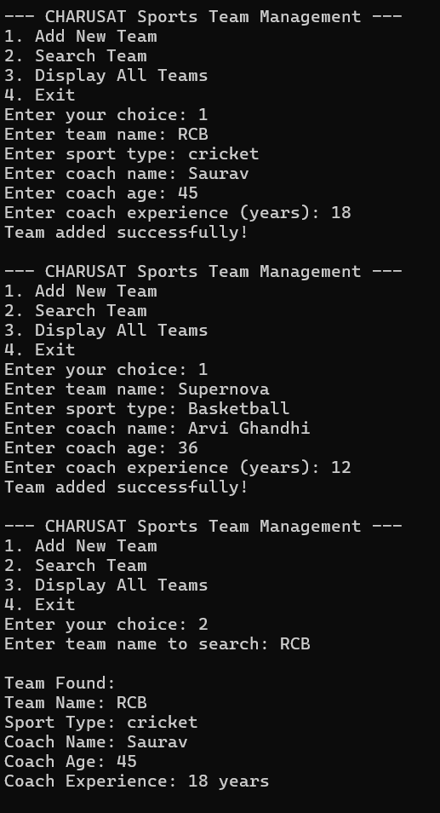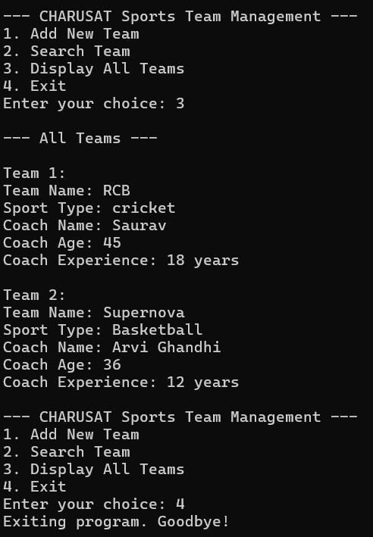

Practical 30
AIM: Use pointers in C to input, sort, and display grocery item prices in ascending order.

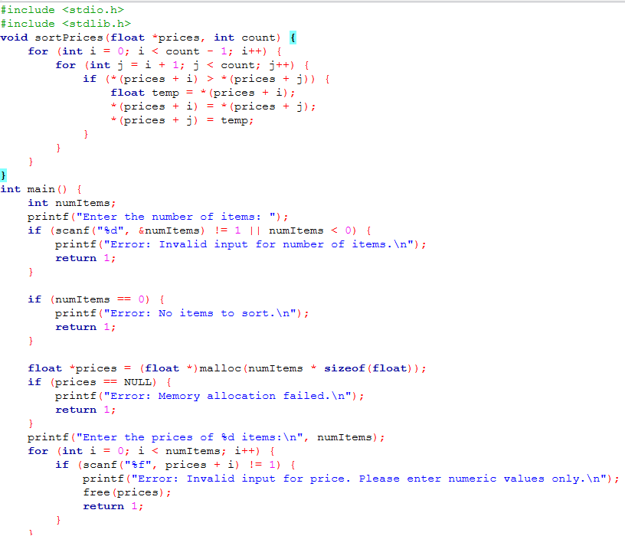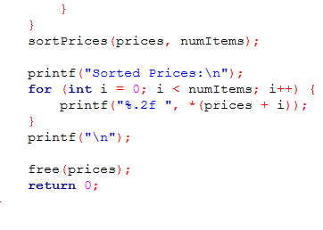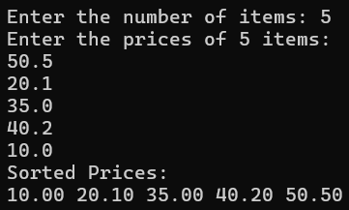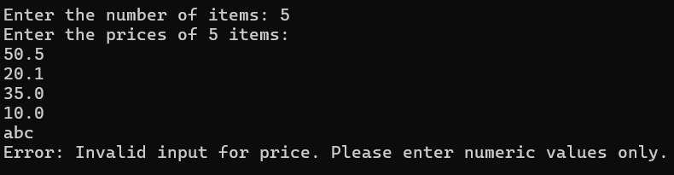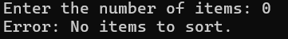

Practical 31
AIM: Use dynamic memory allocation in C to manage and expand article summaries efficiently.

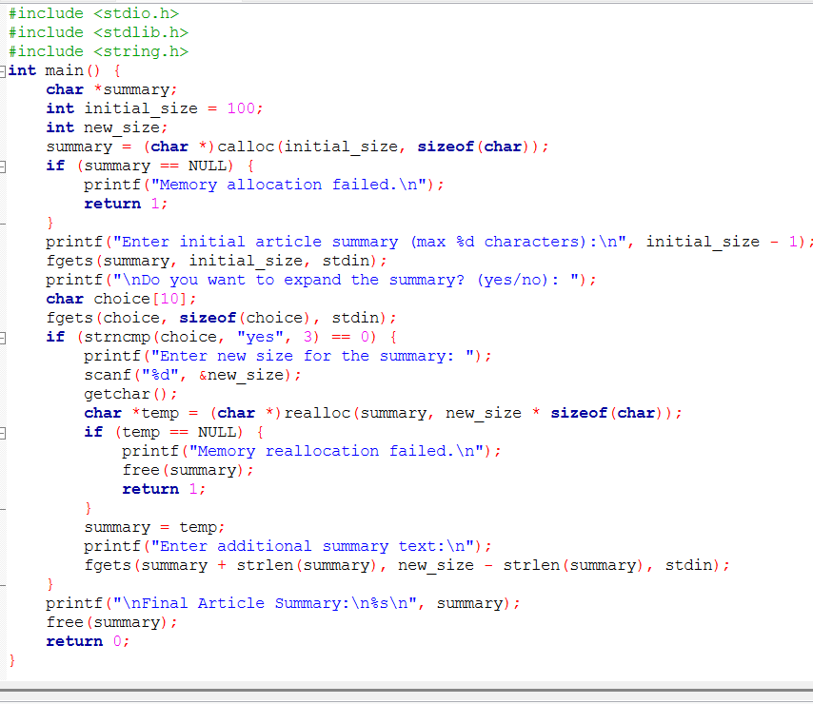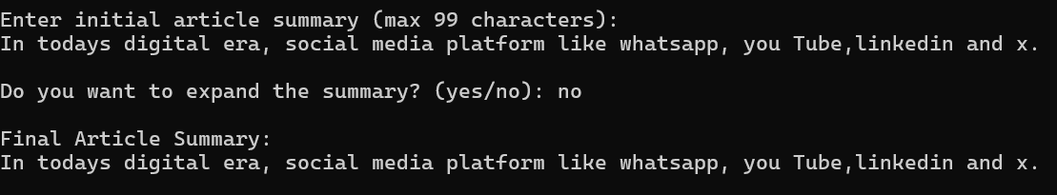

Practical 32 A
AIM: Read a file in C and reverse each word while preserving the original word order.

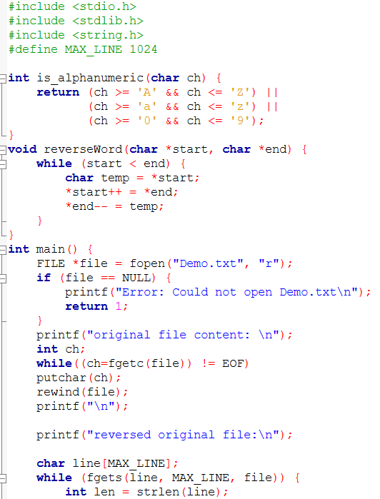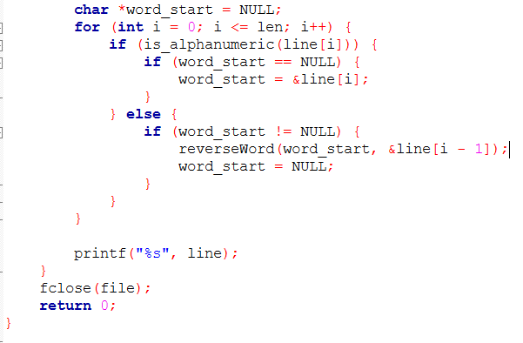
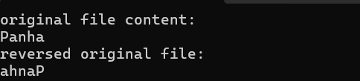
Practical 32 B
AIM: Create a C program to store and retrieve student marks using file operations and putw()/getw().
